

DIGITAL LITERACY PROJECT (CSE0001)

NAME: SNEHA JADHAV
BRANCH:B.Tech CSE (AI & ML)
REG. NO.:25BAI11265

PROJECT BRIEF

Digital Literacy Awareness Project

Deadline: 31 March 2026

Objective:

The main purpose of this project is to create awareness about Digital Literacy among college students and help them develop essential skills for safe, responsible, and professional use of digital platforms. In today’s world, being digitally literate is as important as academic knowledge. This project combines awareness with practical hands-on activities.

Key Deliverables:
- Digital Literacy Awareness Infographic Create a visually appealing, informative infographic using Canva that explains the meaning and importance of Digital Literacy.
- Student Digital Portfolio Design a professional digital portfolio on Canva showcasing personal details, academic background, skills, projects, and achievements.
- Exploration of Coding and Collaboration Platforms Study and prepare a short report on GitHub, LinkedIn, and Stack Overflow, explaining how these platforms are useful for students.
- Professional Email and Etiquette Guide Prepare ready-to-use professional email templates along with a guide on proper digital etiquette.
- Cybercrime Awareness Case Study and Prevention Guide Write a detailed 250-word case study on Cyberbullying covering what it is, how it happens, who is targeted, and its consequences. Also, create a 130-word Social Media Safety and Prevention Guide including Do’s and Don’ts and important reporting channels – National Cyber Crime Portal (cybercrime.gov.in) and Helpline 1930.

Final Output:

All the above deliverables will be compiled into one well-designed, single PDF document.

Learning Outcomes:

This project will help students improve their digital skills, understand online safety, learn professional communication, and become responsible digital citizens.

TASK01: Digital Literacy Awareness Infographic

Tool Used:I created the infographic using Canva.

What the Design Shows:

The infographic is designed as a colourful and easy-to-read poster. It clearly explains:

- What is Digital Literacy? – A simple definition
- Useful Digital Tools for Students – Highlights 6 important tools: Notion, Grammarly, Canva, Quizlet, ChatGPT/Gemini, and Perplexity.
- Safe Internet Practices – Includes 8 short and practical tips such as using strong passwords, thinking before clicking, protecting personal information, and staying safe on public Wi-Fi.

The design uses bold headings, icons, bullet points, and bright colours to make it visually attractive and student-friendly.

One Thing I Found Difficult/Interesting:

The most interesting part was arranging all the information neatly so it doesn’t look crowded. The difficult part was balancing text and visuals. I had to shorten the points a lot to keep the infographic clean and readable.

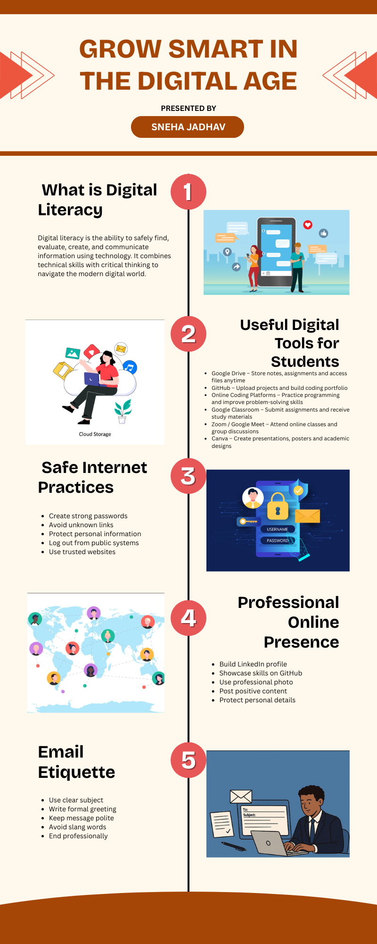
TASK02:Building Student Digital Portfolio

For my Student Digital Portfolio, I chose three powerful platforms: GitHub, LinkedIn, and Kaggle.

GitHub is a platform where I can upload and showcase my coding projects, assignments, and contributions.
LinkedIn helps me build a professional profile, connect with seniors, alumni, and companies, and display my skills and achievements.
Kaggle is an online platform used for learning and practicing data science and machine learning. It provides free datasets, coding notebooks, competitions, and short courses, making it easy for beginners and professionals to build skills and work on real-world problems.

Over the next four years of my college life, I plan to actively use these platforms. I will regularly upload all my academic and personal projects on GitHub to create a strong coding portfolio. On LinkedIn, I will expand my network, share my achievements, and connect with industry professionals. On Kaggle, I’ll learn basics first, then practice machine learning, improve with advanced techniques, and finally specialize and compete to build a strong portfolio.

These three platforms together will help me build a strong digital presence and prepare me for future internships and jobs.

Linkedin
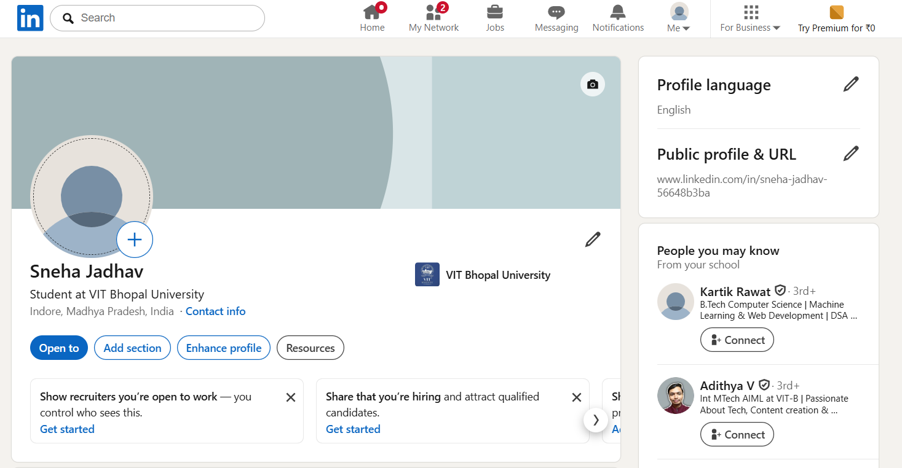
Kaggle
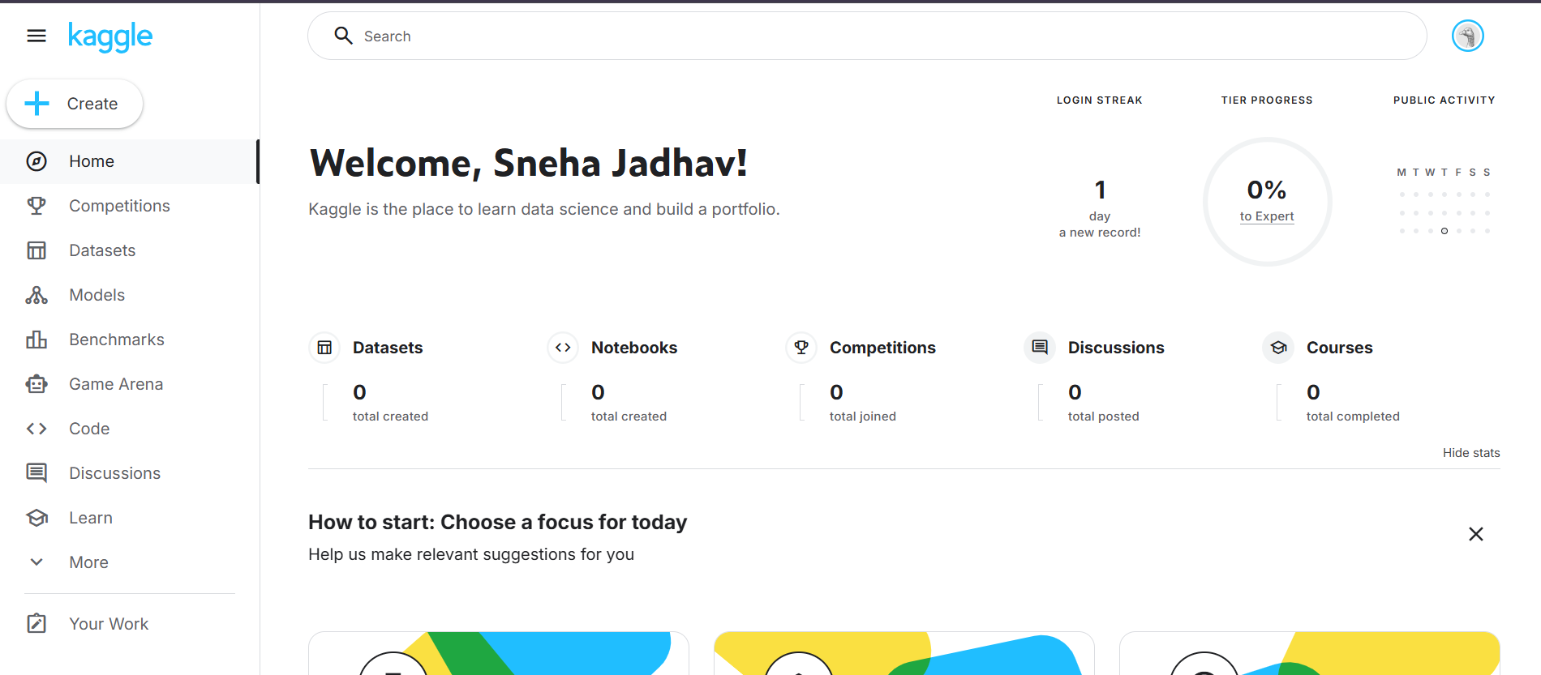
GitHub
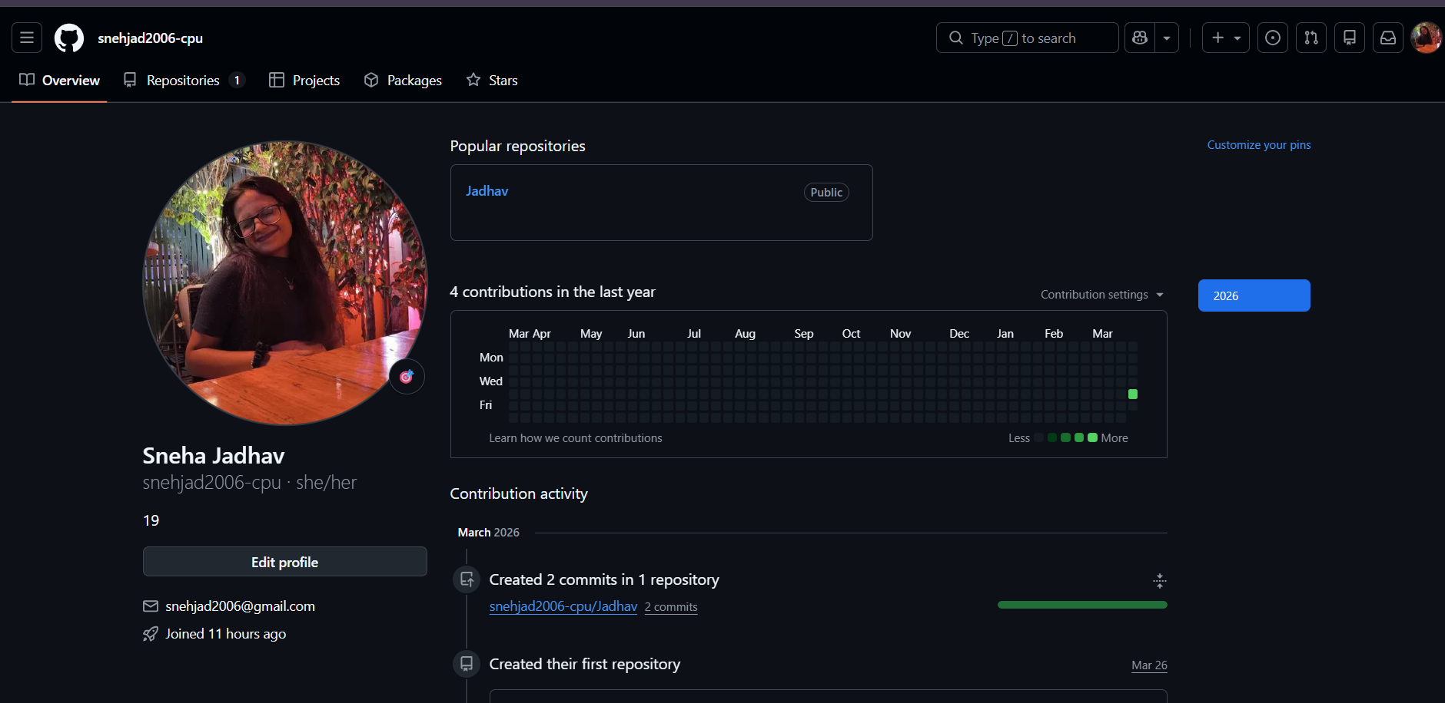
TASK03:Explore Coding & Collaboration Platforms

Part A – Coding Practice (HackerRank)

Tool Used: I used HackerRank for coding practice.

What I Practised:
On HackerRank, I solved beginner-level coding problems to practise programming logic, syntax, and problem-solving skills. The platform provided structured challenges that helped me understand core concepts like variables, loops, and conditions in a hands-on way.

One Thing I Found Difficult / Interesting:
The most interesting part was getting instant feedback after submitting each solution. It showed exactly which test cases passed or failed. The difficult part was debugging errors in my code and figuring out why certain logic didn't work as expected.

Part B – Google Workspace Collaboration (Google Forms Quiz)

Tool Used: I used Google Forms (part of Google Workspace) to create a digital quiz.

What I Built:
I created a Digital Literacy Awareness Quiz for my batchmates with exactly 5 questions. The form includes a mix of multiple choice and short answer questions to test both awareness and personal understanding of digital literacy topics.

One Thing I Found Difficult / Interesting:
The most interesting part was designing questions that felt relevant and relatable for batchmates. The difficult part was framing the short answer questions clearly enough so that responses would be useful and easy to review.

HackerRank:
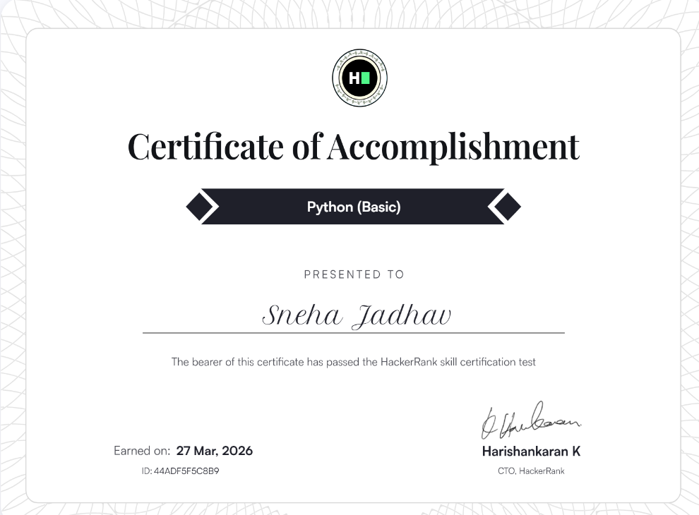

Google Form Link:
https://forms.gle/ScKYY9LA5DeTnmtD6

TASKO4:Draft a Professional Email & Etiquette Guide

Part A – Professional Email Writing

Tool Used: I used Google Docs (Google Workspace) to draft and format both professional emails.

What I Built:
I wrote two professional emails following standard email etiquette rules such as a clear subject line, formal greeting, concise body, and polite closing.

Part B – Responsible Social Media Use: Do's and Don'ts

Tool Used: I used Google Docs and Canva to create a checklist in table format.

What I Built:
A simple checklist of 5 Do's and 5 Don'ts for responsible social media use as a college student.

One Thing I Found Difficult / Interesting:
The most interesting part was realizing how many everyday habits like posting your location or sharing news without checking can actually be irresponsible. The difficult part was keeping each point short and impactful within the word limit.

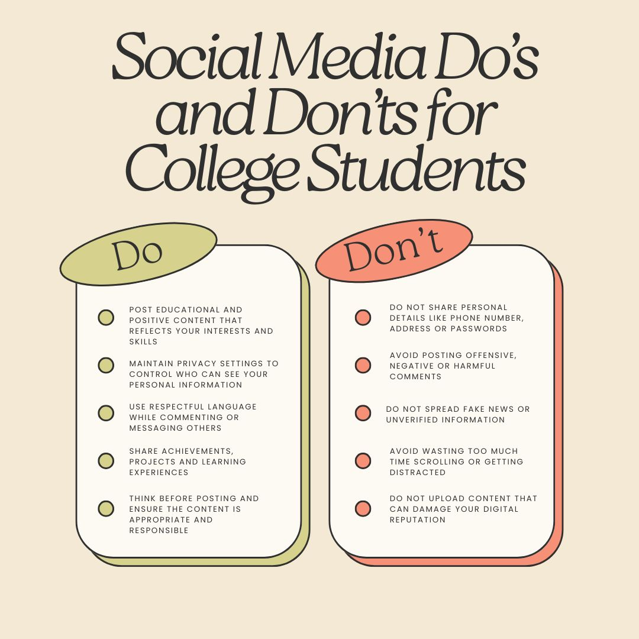

TASK05: Cybercrime Awareness Case Study & Prevention Guide

Part A – Case Study: Cyberbullying

Tool Used: I used Google for research and Google Docs to write and format the case study.

What I Studied:
Cyberbullying refers to the use of digital platforms, social media, messaging apps, or online forums to harass, threaten, or humiliate others. For this case study, I examined a common scenario faced by college students in India: a student receiving repeated mocking comments and morphed images shared across a WhatsApp class group, leading to emotional distress and academic decline.
The case highlighted how cyberbullying differs from traditional bullying: it follows the victim everywhere, operates 24/7, and can reach a large audience instantly.

What Surprised Me Most / One Habit I Will Change:
What surprised me most while researching this topic was that a large number of cyberbullying victims never report the incident either out of shame or because they believe no action will be taken. I also did not realise how severely it impacts mental health, sometimes leading to anxiety, depression, and academic dropout.

Part B – Prevention Checklist: Stay Safe Online

Tool Used: I used Google Docs and Canva to create the checklist.

What I Built:
A practical "Stay Safe Online" checklist with 12 specific, actionable tips for college students in India.

One Thing I Found Difficult / Interesting:
The most interesting part of this task was discovering that India has a dedicated Cyber Crime Portal where students can report online harassment anonymously. The difficult part was selecting only 12 tips from a very long list. Almost every point felt essential and important to include for student safety.

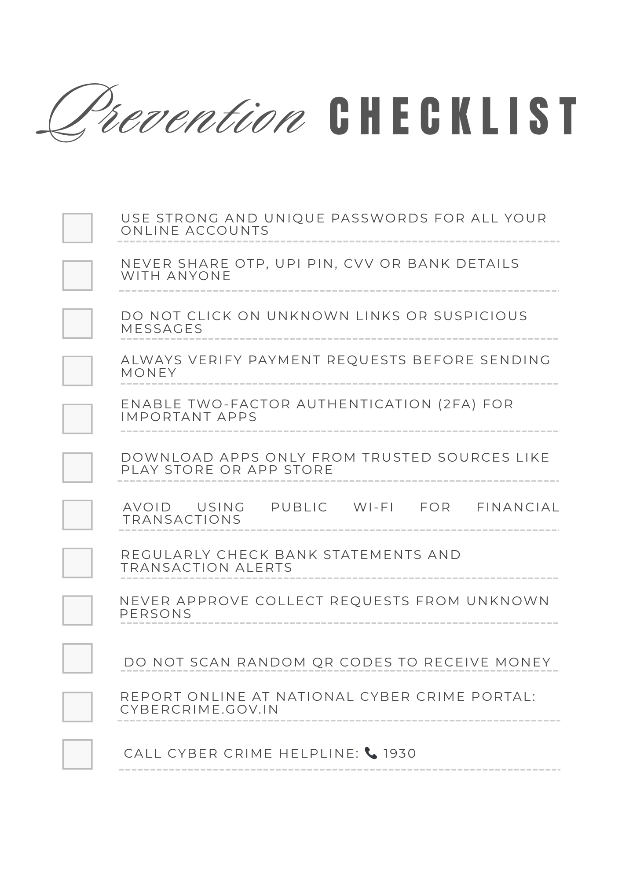

CONCLUSION

This Digital Literacy project has been a valuable learning experience that enhanced my understanding of the digital world and its practical applications. Through the five tasks, I developed skills such as creating informative visual content, building a professional digital portfolio, exploring coding and collaboration platforms, writing formal emails, and understanding cybercrime and online safety. Each task not only improved my technical knowledge but also helped me become more responsible and aware while using digital tools.

I realized that digital literacy is an essential skill for students, as it plays a major role in academics, communication, and future career opportunities. The project also encouraged me to think critically about my online presence and digital behavior. Overall, this experience has prepared me to use technology effectively, safely, and professionally in both my academic and personal life.

REFERENCES

Canva- www.canva.com
GitHub- www.github.com
LinkedIn- www.linked.in
Kaggle- www.kaggle.com
HackerRank- www.hackerrank.com
Google Forms- forms.google.com
Cyber Crime Portal- www.cybercrime.gov.in
Cyber Crime Helpline- 1930(24*7 phone)

